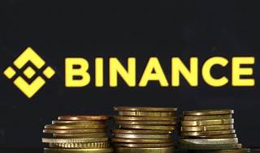

Explore

[**Binance Smart Chain (BSC)** is an innovative blockchain solution that runs parallel to Binance Chain, enabling smart contracts and lower fees through a system of 21 validators using the Proof of Staked Authority (PoSA) consensus1](https://101blockchains.com/binance-smart-chain/)[2](https://www.coinbase.com/cloud/discover/protocol-guides/guide-to-bnb-chain)[3](https://finbold.com/guide/binance-smart-chain/).

Here are **five free reference links** where you can learn more about Binance Smart Chain:

1. [**BscScan**](https://bscscan.com/): Explore and search the Binance blockchain for transactions, addresses, tokens, and other activities[4](https://bscscan.com/).
2. [**An Introduction to BNB Smart Chain (BSC)**](https://101blockchains.com/binance-smart-chain/): Understand the mechanics of BSC and its interoperability features[1](https://101blockchains.com/binance-smart-chain/).
3. [**Guide to BNB Chain**](https://www.coinbase.com/cloud/discover/protocol-guides/guide-to-bnb-chain): Learn about BNB Chain’s compatibility with Ethereum Virtual Machine (EVM) and smart contracts[2](https://www.coinbase.com/cloud/discover/protocol-guides/guide-to-bnb-chain).
4. [**Binance Smart Chain (BSC) Explained**](https://finbold.com/guide/binance-smart-chain/): Dive into the purpose and differences between BSC and Binance Chain[3](https://finbold.com/guide/binance-smart-chain/).
5. [**How to Get Started with BNB Smart Chain (BSC)**](https://academy.binance.com/en/articles/how-to-get-started-with-binance-smart-chain-bsc): Practical information on getting started with BSC[5](https://academy.binance.com/en/articles/how-to-get-started-with-binance-smart-chain-bsc).

Happy learning! 🚀🌟